**Savan** Installation Guide

Savan is designed to reduce the effort of loading the reference project which we might not actually using it, but sits ideally in our workspace for module reference. Savan will replace those module projects with jar references.

Download the Zip file and save it local as Savan.zip.

<https://er49.deloitteonline.com/eRoom/SGPM/VAIntegratedEligibility/0_cd6bf>

Step1 : Open Eclipse/RAD

Browse to help menu and select install new software.

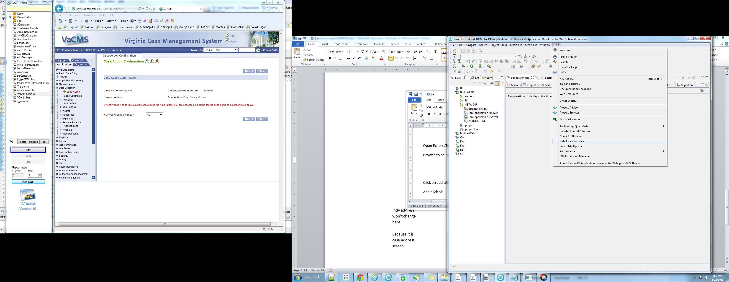

Step 2: Click on Add, A pop up will show up.

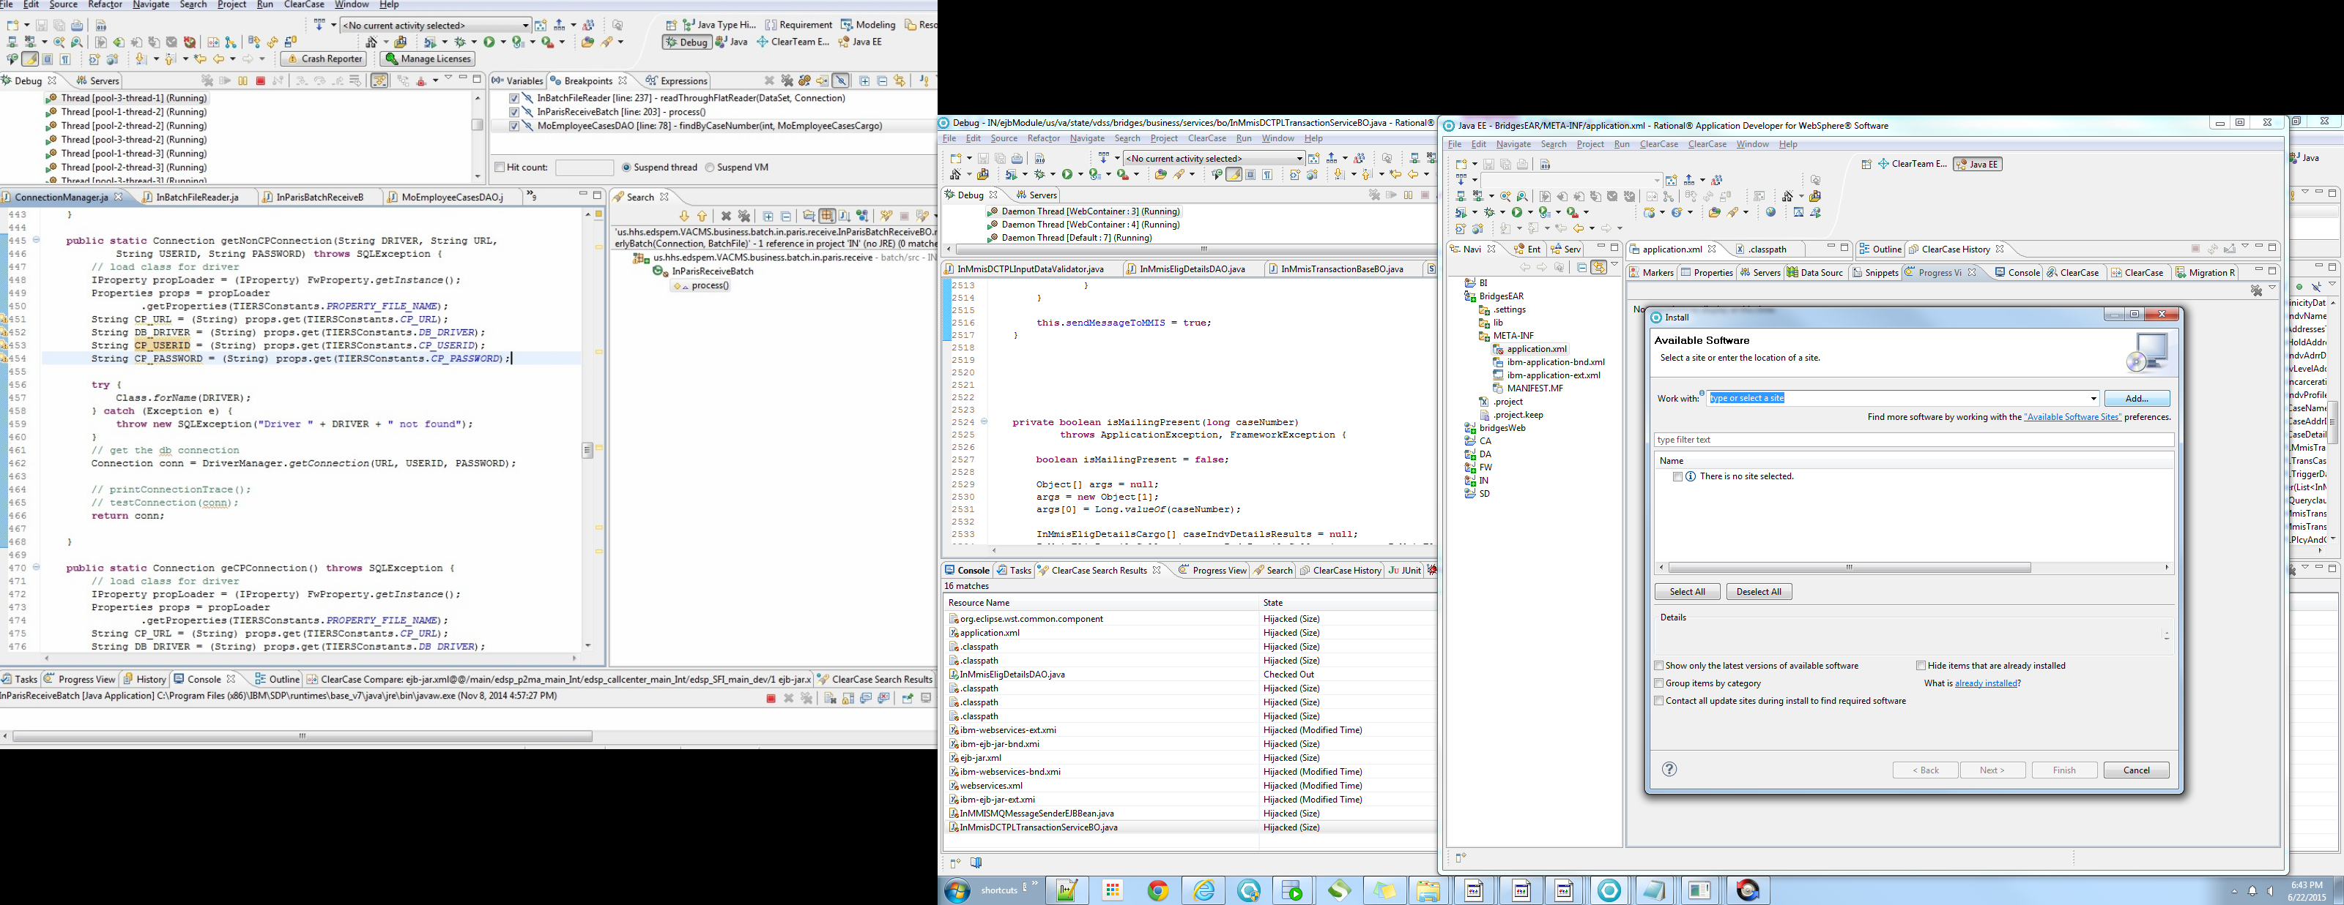

**Step 3: Click archive:**

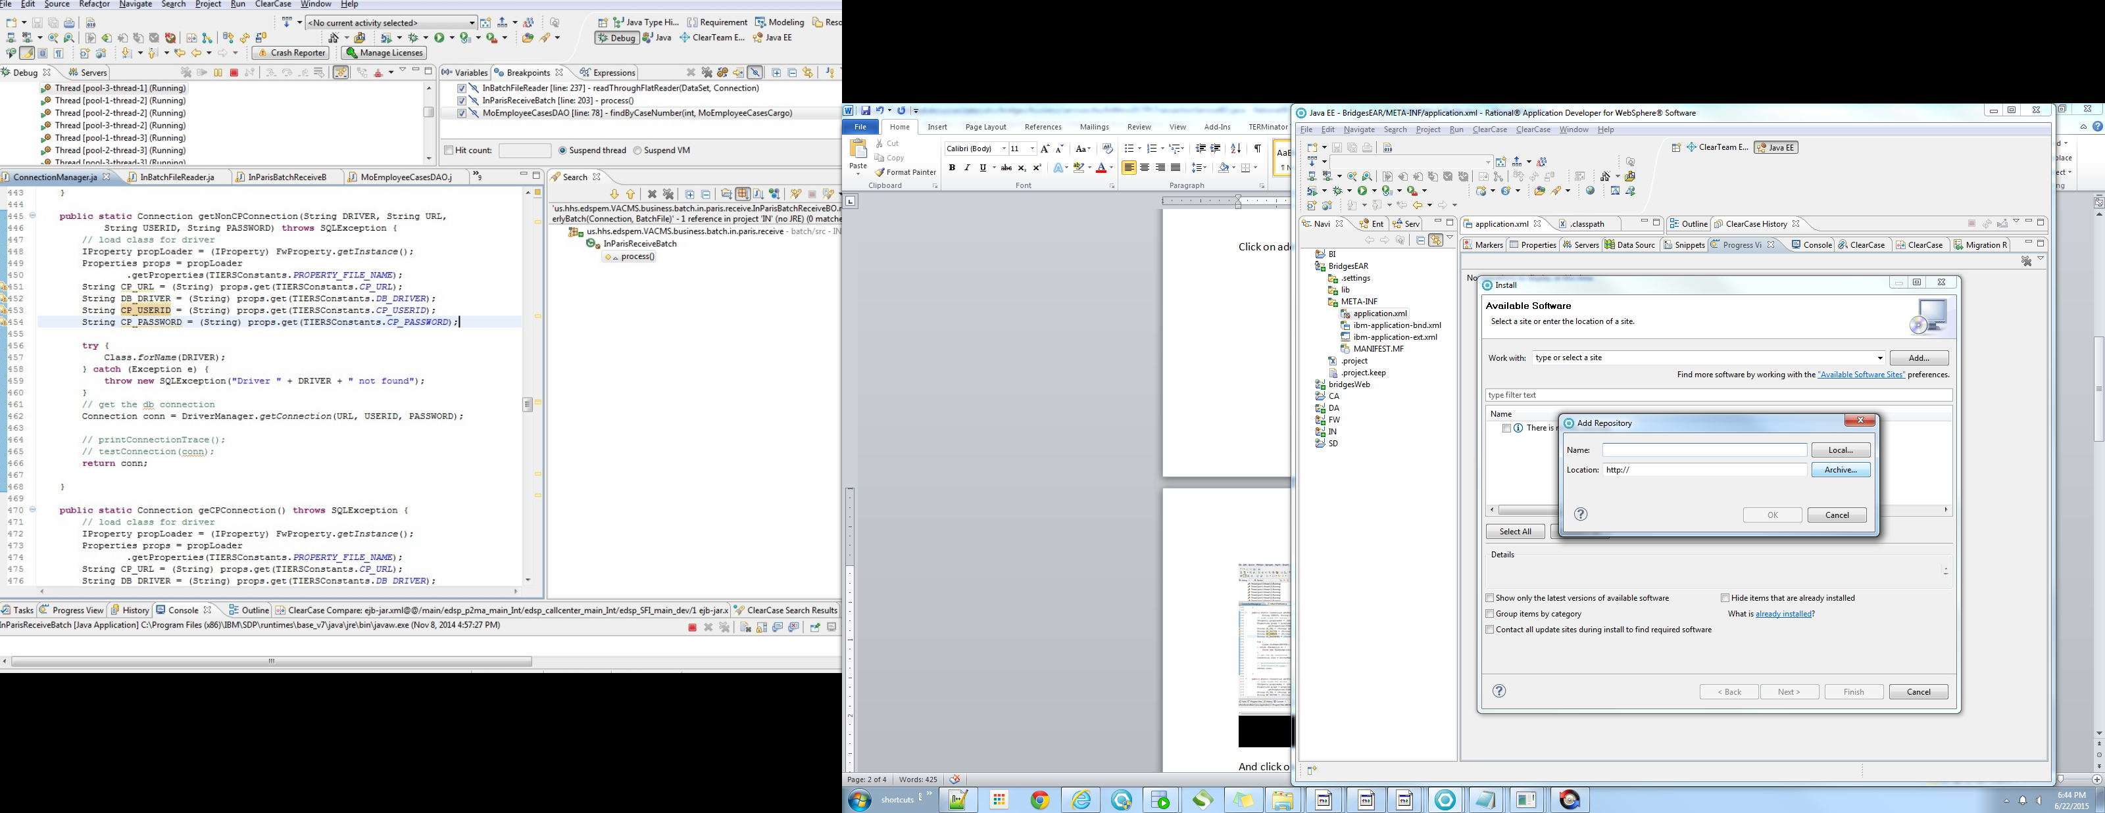

Step 3: Browse and select **Savan**.zip:

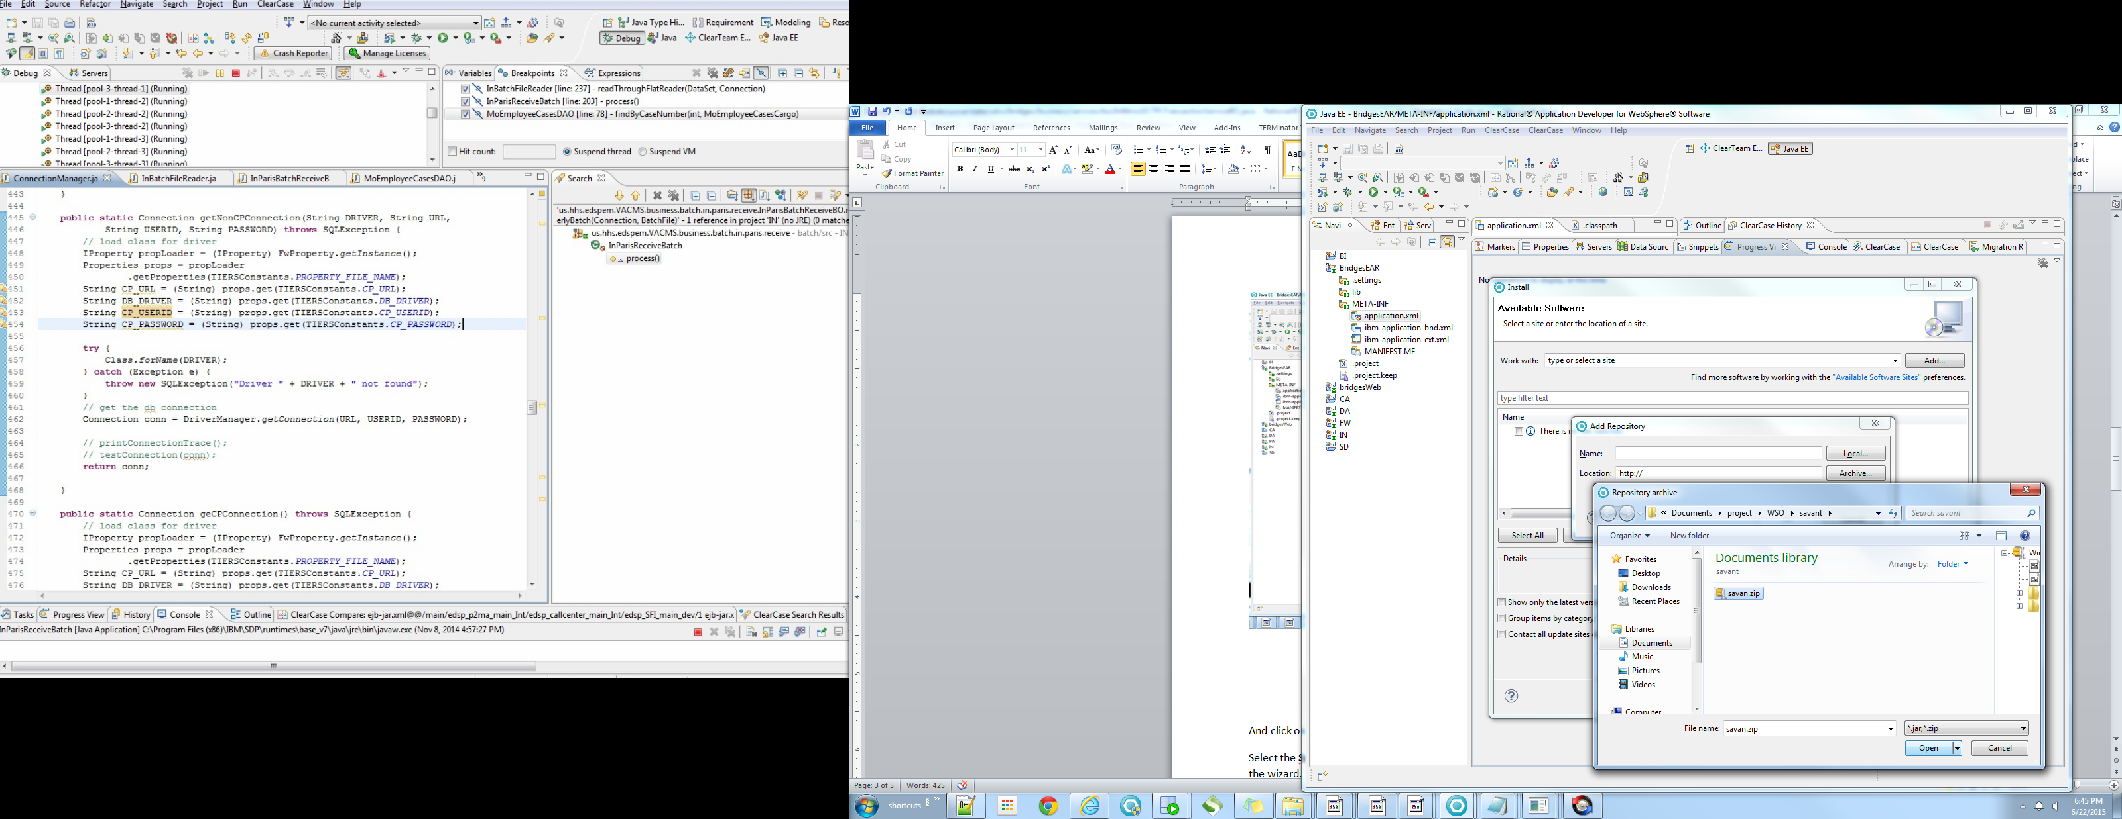

**Step 4: Click ok:**

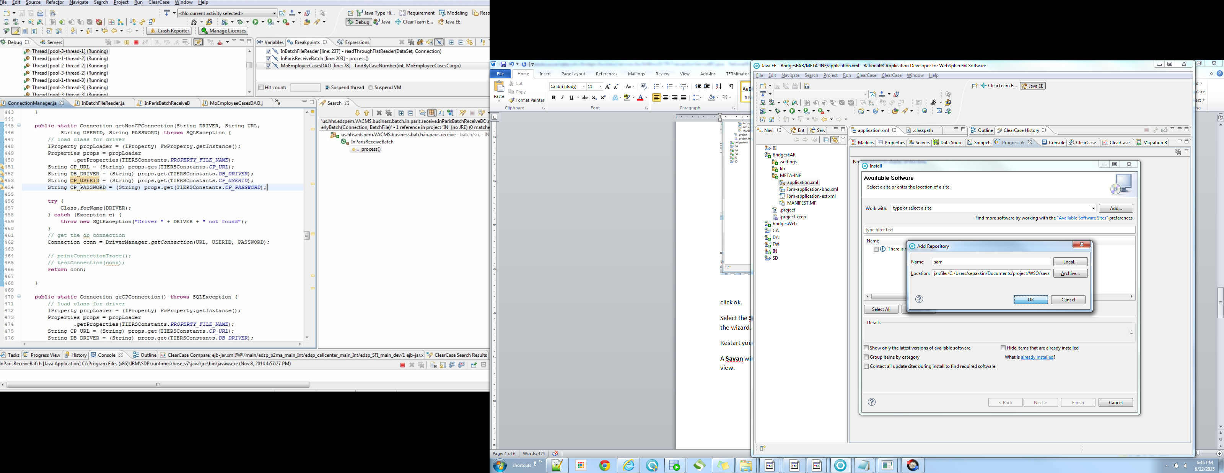

Step 5: Click on Select All and click on next, accept the license agreement and click next and finish the wizard. Restart the eclipse/RAD to adopt the changes

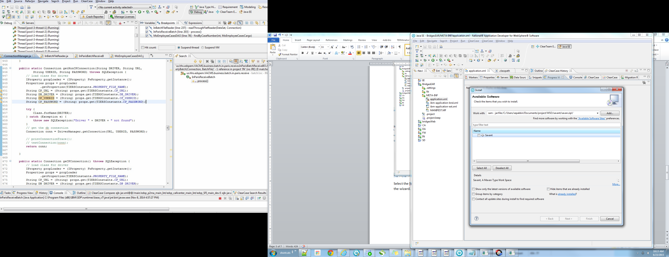

Step 5: Restart your eclipse. Browse to window menu select view and search for **Savan** and select.

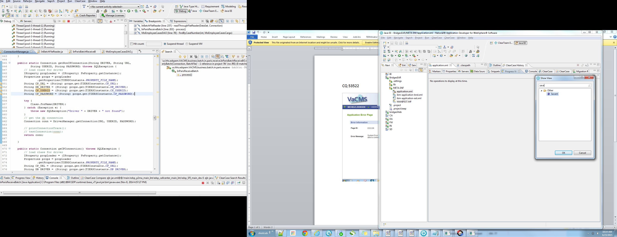

Step 6: A **Savan** window will appear with table grid and 3 control buttons on the top right corner of the view.

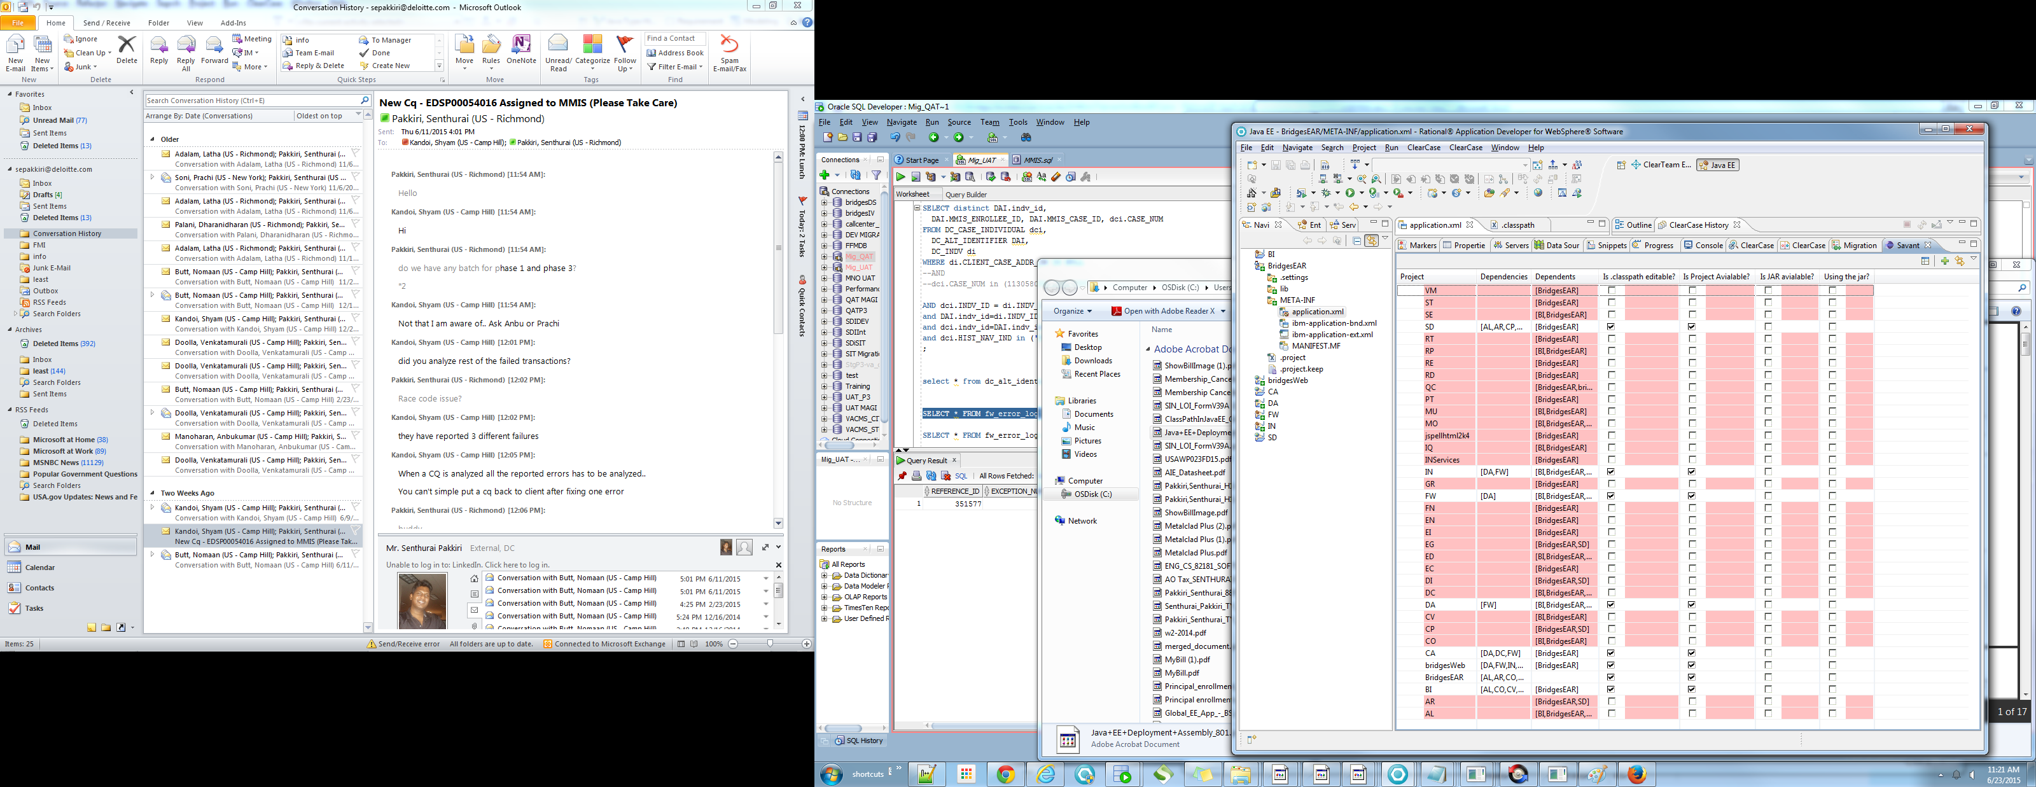

There are three controls on the right top corner : FTP config, **Savan** config and refresh button.

Step 7: Ftp config allow you configure the ftp server name, port number user name and password. You need to specify the jar folder path and u can able to test the ftp connectivity by clicking on ftp button. Also u can able to test the existence of the ftp folder path. Once you test the connectivity and the existence of folder path, click on ok to download the jar required for the workspace.

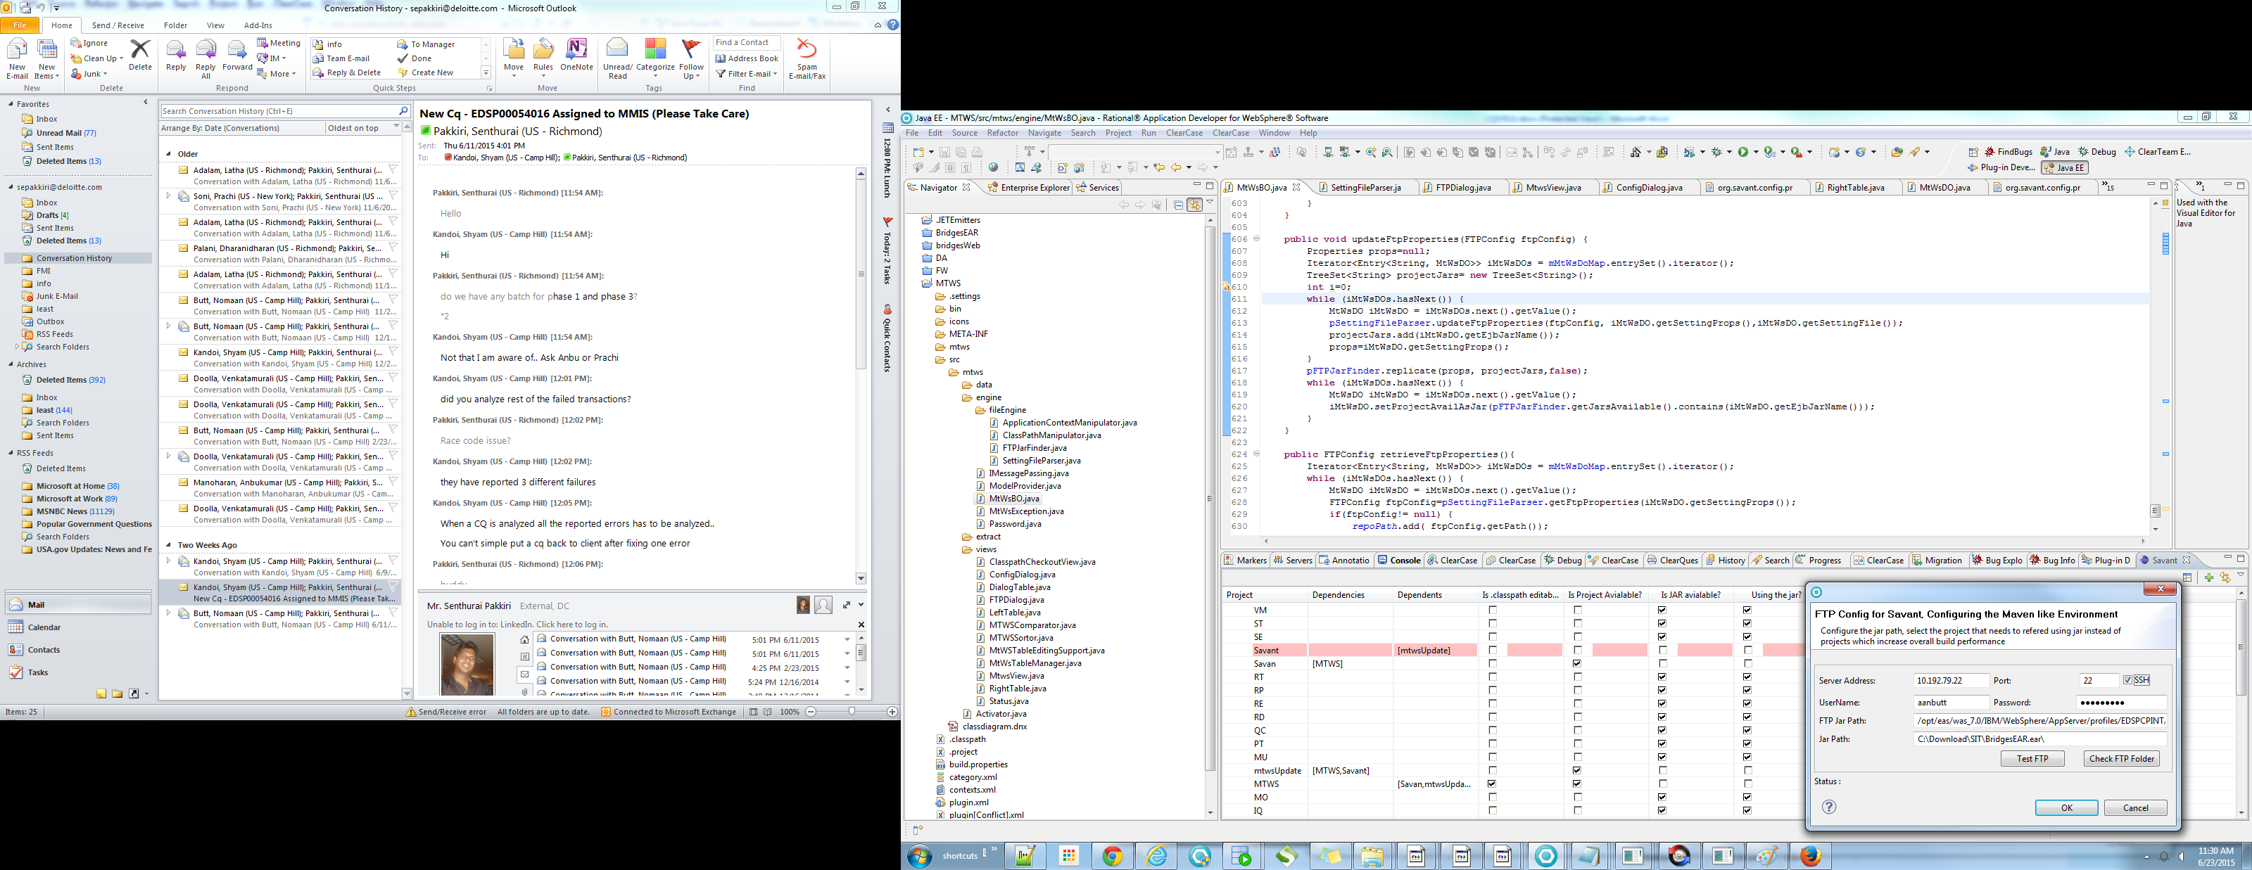

Step 8: Click on refresh button.

The table view shows you the number of work space projects and the along with the referred projects which may or may not present in the workspace. You could able to cross check the existence of project in workspace by checking against the column “is project available?”

Also you could able to cross check whether the project is available as jar file or not.

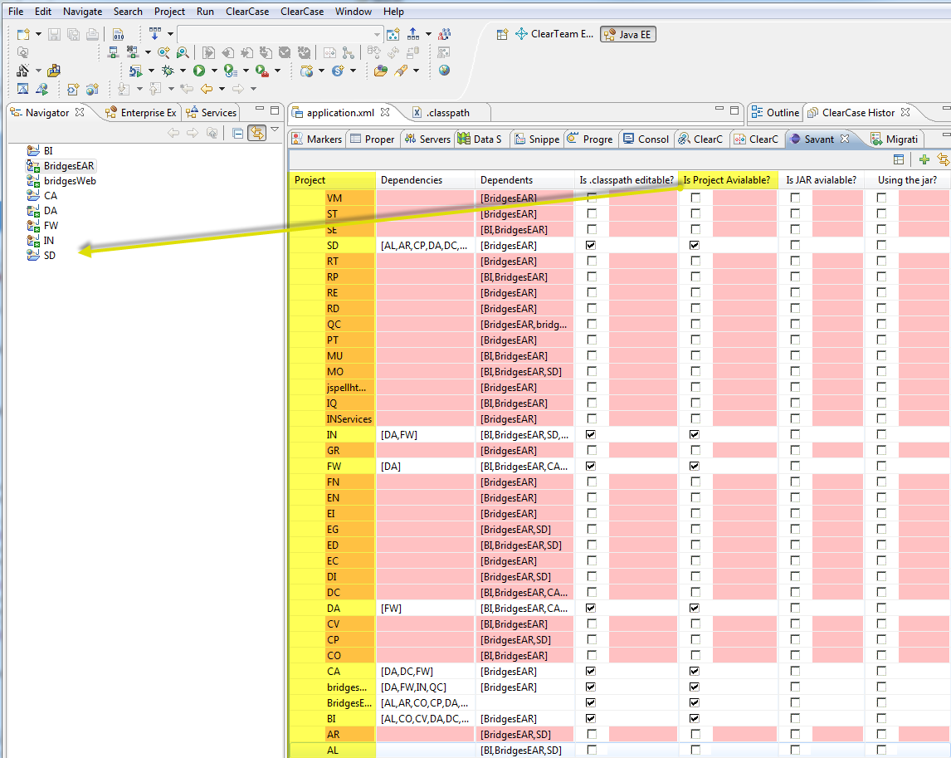

Step 9: You could able to close the unwanted project and refer against the jar file available. This is possible by clicking on right top corner of the **Savan** window.

Click on **Savan** Config button, a pop up will appears with the projects available with jar available on your right. You can able to select those projects to be referred as jars and it will close those projects if available.

This is possible by double clicking on the project showed on right hand side. Once you double click those projects, it will be loaded to your left side column.

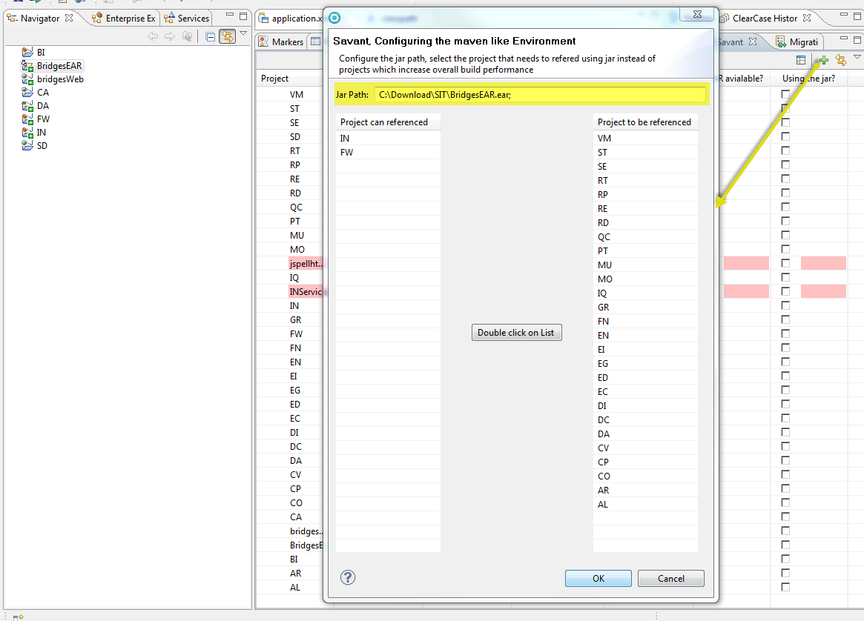

Once you are set, click on ok. This will replace all your project reference as a jar reference which you are on right hand side.

Step 10: Click on refresh

You can able see few projects highlighted in red background for which the project and the jar both are not available. You need to manually take care of these projects.

This will set all your workspace .Once there is no red highlights you can able directly go to build and deploy the application else go to application.xml in your EAR to manually fix the issue